1. **Agenda**:
   1. Simple REST Controller and return some hard-coded text.
2. 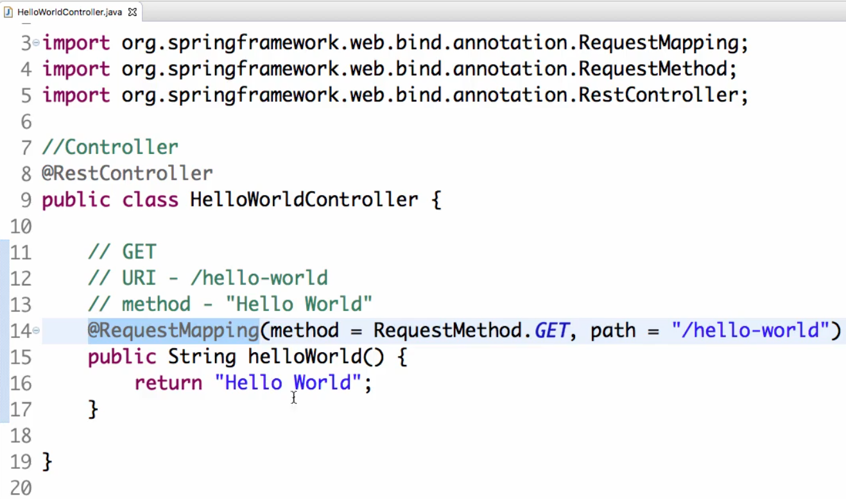
3. 